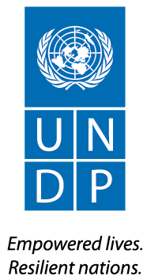

Development Effectiveness
  - Output Board Report

INTRODUCTION
UNDP’s programme on Democratic Governance, which started in April 2013, aims to improve the overall institutional environment in which citizens interact, and within which economic, political, legal and administrative authority are exercised. This was one of three programme outcomes identified in the UNDP CPAP, approved in April 2013.

Under the Democratic Governance programme, UNDP works in partnership with the Ministry of National Planning and Economic Development to enhance development effectiveness. The objective of this area of work is to strengthen the capacity of institutions to collect and analyze data, set development priorities and formulate and implement policies, strategies and plans, and manage development aid effectively.
Pillar 3: Democratic Governance
Output 1: Strengthened capacity of national institutions for socio-economic policy-making, planning and development effectiveness with broad stakeholder participation (including women, people with disabilities and HIV/AIDS).
Key Partners: MNEPD Planning Department, FERD, Statistical Department, Department of Investment and Company Administration; President’s Office; Central Foreign Aid Management Committee; Ministry of Finance; Ministry of Industry; Development partners; NGOs, CSOs and CBOs, media
Key Activities into Results 2013:
- Capacities of design, collection and analysis of socio-economic data strengthened and developed.
- Strengthened planning institutional architecture.
- Strengthened policy-making and planning capacities of key institutions
- Establishment and operation of the Aid Management Information System.

Funded by: AUSAID and UNDP
Approved Budget: USD $ 1,708,795
Cumulative Expenditure: USD $801,668
Delivery: 46.9%

SUMMARY
In 2013, UNDP has laid the foundations for future work with government and international partners on planning, statistics, and aid information management. UNDP has made incremental improvements to the planning architecture at national level, and supported greater coordination across ministries. UNDP has launched an economic census, targeting businesses, which will inform future data collection regarding national investment statistics: this work is helping government to establishing a base of data on national accounts.

PROGRESS AGAINST KEY RESULTS

Sub-Output 1.1: Planning and statistics

This area of work supports enhanced capacity to collect and analyse data, to inform planning and policy development, and improved capacity for inclusive, effective and participatory planning.

Statistics and System of National Accounts
In previous years, UNDP supported the roll-out of the Integrated Household Living Conditions Assessment to measure quantitative indicators of household living conditions. In 2013, UNDP worked with the existing data from the Integrated Household Living Conditions Assessment and other surveys to provide analysis for policy makers. UNDP produced thematic reports using the IHLCA and other qualitative and quantitative data which make data more accessible for partners in other government departments. The reports covered the following topics:
- Transport infrastructure and trade in Myanmar;
- Access to finance in Myanmar;
- The role of remittances for poor and non-poor rural and urban households in Myanmar;
- Causes of poverty and potential strategies for poverty reduction in Myanmar, and
- Regional development strategy reports for Bago, Ayeyarwaddy, Magway, Mon, Chin, Mandalay and Shan.
UNDP presented the first three reports, in separate sessions, in Yangon and in Naypyitaw to 186 participants, including senior government officials, UN organizations, and related stakeholders.

Effective calculation of GDP will be a keystone of national accounts. Under the International Comparison Programme (ICP), UNDP provided both technical and financial assistance to the Ministry of National Planning and Economic Development’s Planning Department to collect and analyse data on the price of household and non-household items for 2012, and verify them for 2013. These were shared with the Asian Development Bank to support calculation of Purchasing Power Parity (PPP) for Myanmar. At the request of the government, UNDP supported preparation for an economic census, which will feed into future efforts to calculate Gross Domestic Expenditure (GDE) through an economic survey. UNDP prepared a sampling form and survey tools, and trained 153 civil servants (84 women) on data collection and data entry, for the upcoming registered economic census, in November 2013. The census will target an estimated 57,600 businesses in all regions.

Planning

UNDP provided technical assistance to strengthen national planning systems and architecture, and to support the development of a National Comprehensive Development Plan (NCDP), leading to a more clearly articulated vision and a more robust technical foundation for national plans.

UNDP completed an assessment of the existing planning architecture, noting that approval is highly centralized, that planning systems are highly institutionalized/centralised and uni-dimensional, with limited scope for greater inclusivity, and that the legislative basis for planning needs to be strengthened. This assessment informed an action plan for establishing an improved poverty-focused planning and monitoring infrastructure at the Union and state/region level, linked to planning activities at the district level, and an improved model for planning architecture with greater linkages amongst regional and state level planning units.

Based on an informal assessment of capacity gaps, the UNDP technical consultant to the NCDP developed a workshop-based training plan for the planning department on planning concepts and methods, including understanding theories of change, how to conduct strategic prioritization, multi-criteria analysis techniques and new public management. UNDP led the first workshops on Theory of Change methodology, training 55 participants, including 37 civil servants (20 female) at central and state/division level, providing an overall understanding of the Theory of Change planning methodology, and developing a pathway of change for selected strategies linked to the NCDP. These training workshops have improved the understanding of basic concepts in planning, which in future will encourage more coherent planning processes.

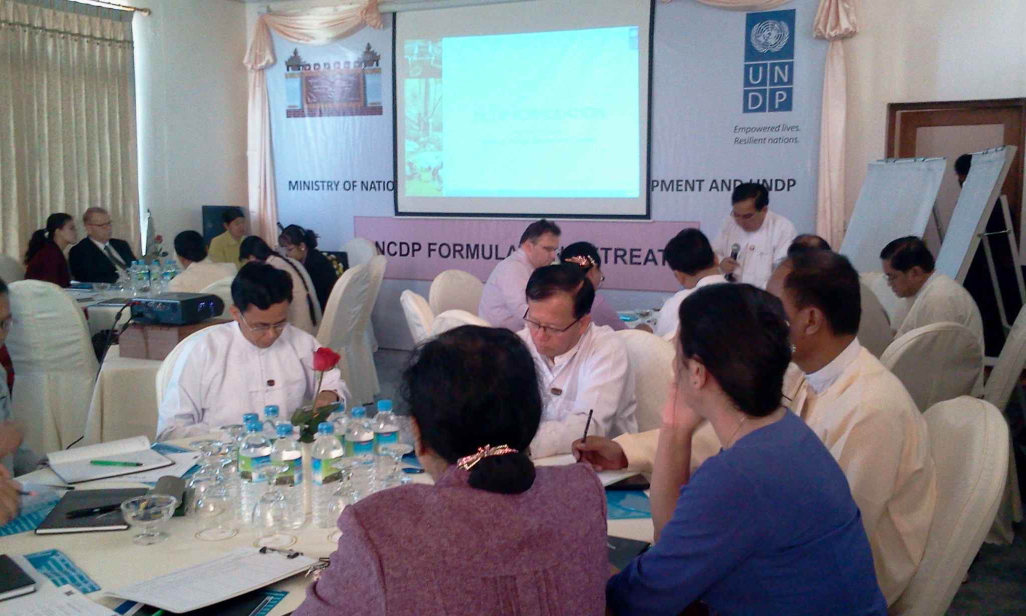
To bolster cross-government collaboration and the inclusion of regional priorities and enhanced technical perspectives into the NCDP, UNDP designed and agreed a programme of retreats for the Planning Department of the MNPED. The objectives of the retreats are to broaden stakeholder participation within the NCDP formulation process, and to support a consensus based approach to development planning. UNDP provided financial and technical support to the first retreat in Mandalay in November 2013, attended by more than 52 officials and civil servants (23 female), as well as by parliamentarians, and international development partners. The focus of the retreat was on land ownership issues, deforestation, loan settlement/microfinance to farmers and certification of products and water supply for paddy fields.

Building on this work, UNDP provided technical advice to the Planning department on the drafting of the first two chapters of the NCDP, and on the integration of regional priorities into national plans.

To strengthen regional planning systems and architecture, UNDP provided an advisor to the Planning Department, who has completed an assessment of the regional planning architecture and developed recommendations for the improvement of Regional Comprehensive Development Plan process. Work in this area is expected to pick up pace in 2014.

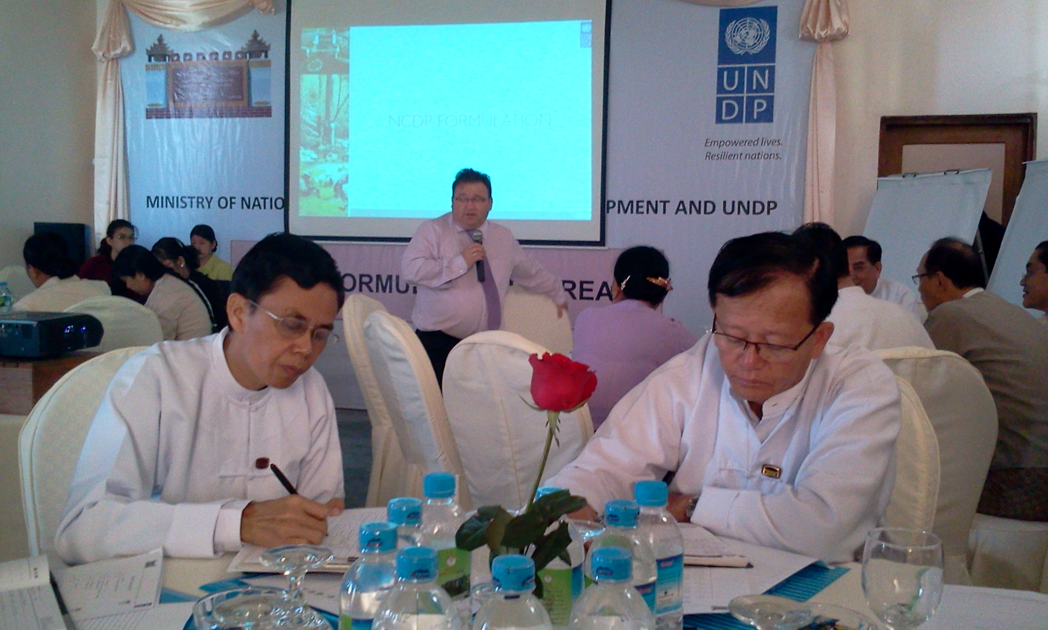
UNDP also completed preparatory work towards an assessment of the socio-economic impact of HIV at the household level, in alignment with the priorities of the National Strategic Plan of HIV and AIDS (2011-2015). UNDP advised on the establishment of a Steering Committee, which includes representatives from Ministry of Health; Ministry of National Planning and Economic Development; Ministry of Social Welfare, Relief and Resettlement; Ministry of Labour, Employment and Social Security General Administration Department, as well as UN agencies and civil society, which will provide oversight for this assessment. The assessment will provide policy recommendations for HIV impact mitigation and HIV sensitive social protection.

UNDP is committed to mainstreaming poverty-environment linkages into national development and sub-national development planning. In 2013 preparatory work has been done to establish the Poverty Environment Initiative (in partnership with the United Nations Environment Programme (UNEP)) in Myanmar, to support the Government of Myanmar in enhancing pro-poor and environmentally sustainable planning and to develop a programme of activities for 2014 to promote, negotiate and manage quality private investment.

Sub-Output 1.2: International aid cooperation and information management

This output supports enhanced government capacity to coordinate and manage external assistance. UNDP contributed to aid coordination agenda by providing technical advice to the Foreign Economic Relations Department (FERD), on the development of an AIMS, the collection of aid information and production of reports from the system.

UNDP provided technical advice to the FERD to enhance institutional capacity and drafted a Development Assistance Guidance note, as well as a report for the FERD on programme strategies and funding envelopes for the main bilateral and multilateral development partners operating in and for Myanmar up to 2014. UNDP developed and began implementing a training schedule for FERD staff, delivered by an international consultant (these one day weekly sessions were regularly attended by 46 FERD staff (36 female)).

GENDER
UNDP worked with the Ministry of Social Welfare to support the implementation and monitoring of the National Strategic Plan for Advancement of Women (NSPAW).

PARTNERSHIPS WITH OTHER ACTORS
As well as strengthening national mechanisms for coordination, UNDP has been moving towards more coordinated approaches with other international actors, including participation in the Statistics Working Group (which includes the World Bank and the Asian Development Bank), work with the Asian Development Bank on NCDP formulation, and work with the EC team on aid information management. Greater efforts in 2014 to improve partnerships will be needed.

FREQUENTLY ASKED QUESTIONS

Q. What is CPAP?
A. Country Programme Action Plan is the agreement signed between UNDP and Government of Myanmar regarding the programmes/ activities to be implemented by UNDP between 2013-2015.

Q. What are the main UNDP programmes under the CPAP 2013-2015?
A. There are three main UNDP programmes under the CPAP (also referred to as “Pillars”): 1. Local Governance; 2. Environment, Climate Change, Energy and Disaster Risk Reduction (DRR); & 3. Support to Democratic Governance in Myanmar.

Q. Under which Pillar does the Programme on Rule of Law and Access to Justice (RoL/A2J) fall?
A. The RoL/A2J Programme (also referred to as an “output”) falls under Pillar 3 i.e. Support to Democratic Governance.

Q. What is a Programme Document (Prodoc)?
A. Each of the 3 programmes/pillars has a Programme Document (prodoc) that describes the programmes/outputs, which will be implemented under each Pillar for the period 2013-2015. The prodocs are a part of the signed CPAP (as annexes).

Q. What is an RRF?
A. The Results and Resources Framework is part of the prodoc and describes the broad results sought to be achieved, the indicative activities which may be implemented to achieve those results and the financial resources available/needed to implement the activities.

Q. What is an AWP?
A. Each Output has an Annual Work Plan (AWP), which describes in detail the activities for a particular year within the CPAP cycle (2013-2015)

Q. Is the AWP also signed (every year)?
A. The AWP is not signed but draws its guidance from the CPAP, the prodocs (including the RRF) and the national priorities.

Q. Can the RRF & /or the AWP be changed?
A. The RRF & AWP can be changed, if the circumstances require this. While mid-course corrections for AWPs are quite common, RRF is changed in exceptional cases.

Q. Who approves the changes to the RRF or the AWP?
A. Output Boards created under each “Output” of each “Pillar” are the governance structures that approve these changes.

UNDP GOVERNANCE STRUCTURES
Tier 1 - Output Boards
Core task: results management.
Decision prerogatives: approve Output Annual Work Plans; endorse Output Annual Progress Reports; review Output Results and Resources Frameworks (RRFs) and, if necessary, recommend changes to Pillar Boards; other decisions as delegated by Pillar Boards and as per UNDP rules and regulations.
Membership: 1-2 main government counterparts per output; 1 donor per output; UNDP; other partners as agreed upon between UNDP, government and donors; all participants at technical level (e.g. Output lead for UNDP; Director-level for government).
Frequency of meetings: twice a year.

Tier 2 - Pillar Boards
Core task: quality assurance of results; programme coherence and strategic focus.
Decision prerogatives: approve Output RRFs and, on this basis, Pillar RRF; consider recommendations and approve changes to RRFs (except substantial changes to be reviewed by the Steering Committee, ref below); provides overall guidance to Output Boards on Annual Work Plans; where appropriate, recommend alignment with Sector Working Groups; endorse Annual Pillar Progress Reports; other decisions as delegated by the Steering Committee and as per UNDP rules and regulations.
Membership: 1-2 main government counterparts per each output; 1-2 donor per pillar; UNDP; other partners as agreed upon between UNDP, government and donors; all participants at management level (e.g. Pillar team leader for UNDP; Director-General-level for government).
Frequency of meetings: twice a year.

Tier 3 – Steering Committee
Core task: strategic direction and overall alignment with national priorities.
Decision prerogatives: conducts annual country programme review; provides overall guidance to Pillar Boards on their respective RRFs; approves substantial changes in the RRF, such as concerning deletion, addition or amalgamation of entire outputs; commissions independent evaluations and approves UNDP management responses; considers overall duration of the programme cycle in line with evolving national priorities and timelines and makes appropriate recommendations to Government and UNDP.
Membership: all government counterparts and all donors; UNDP; UN agencies; other partners as agreed upon between UNDP, government and donors; all participants at executive level (e.g. Country Director for UNDP; Deputy Minister for government).
Frequency of meetings: once every year.

Sub-output 1.1: Key government institutions develop national and regional plans using up to date, accurate and gender disaggregated poverty data.
Including representation from the Ministry of National Planning and Economic Development, Ministry of Transport, Ministry of Construction, Ministry of Trade, Ministry of Finance and Revenue, Ministry of Agriculture, Ministry of Labour, Ministry of Cooperatives, Myanma Agriculture Bank, Ministry of Health, Ministry of National Registration and Population.

